

Vel Tech Rangarajan Dr. Sagunthala R&D Institute of Science and Technology (Deemed to be University Estd. u/s 3 of UGC Act, 1956)
School of Computing
B.Tech. – Computer Science and Engineering
VTR UGE2021- (CBCS)

Academic Year: 2025–2026
SDG 4: Quality Education Course Code : 10211CS207
Course Name : Database Management Systems Slot No : S6 L6

DBMS PROJECT REPORT
Title: AIRLINE MANAGEMENT SYSTEM

Submitted by:

VTUNO | REGISTER  NUMBER | STUDENT NAME
VTU30305 | 24UECS1404 | TELAPROLU.NAGA RAGA PALLAVI
VTU28520 | 24UECS0480 | CHAVALI.USHA
VTU28250 | 24UECS0617 | KAILAM.CHARISHMA
VTU28954 | 24UECS0820 | PATIL.THARUN REDDY
VTU27799 | 24UECS0774 | NANDYALA.SANTHOSH REDDY

Under the guidance of
Dr.Umanandhini.D
Associate professor

INDEX
S.NO | Name | Page.no | Sign
1. | Introduction | 3
2. | Problem statement | 4
3. | Objectives | 5
4. | System requirements | 6
5. | System analysis and design | 6
6. | Er diagram | 7-10
7. | Schema design(oracle) | 11-12
8. | Normalization | 13-14
9. | Implementation(sql queries) | 15-16
10. | Input/output | 17
11. | Integration with mongodb(no sql) | 18-19
12. | Result and discussion | 20
13. | Conclusion | 20

Introduction

An airline management system uses a database management system (DBMS) to store and manage all critical airline data, such as flight schedules, passenger reservations, ticket records, and employee information. The DBMS ensures data consistency, security, and efficient retrieval, allowing for streamlined operations like ticket booking, real-time updates, and reporting. By organizing this complex data, the system improves efficiency and enhances the customer experience.
Normalization is applied to the database to eliminate anomalies and ensure data consistency and integrity. The DBMS also provides security features to control access to sensitive data, such as passenger personal and payment information.
The system can generate various reports, such as flight schedules and passenger manifests, which are essential for both administrative and operational purposes. By querying the database, airlines can gain insights for decision-making.
The DBMS allows for real-time updates to flight status, availability, and pricing, providing accurate information to both customers and internal staff.

Problem Statement

In the traditional airline management system, most operations such as ticket booking, seat allocation, flight scheduling, and passenger record maintenance are handled manually. This manual approach leads to numerous challenges,including data redundancy, inconsistency, delayed service, and difficulties in record management. As the volume of passengers and flight services continues to grow, maintaining large amounts of data manually becomes inefficient and prone to errors. Retrieving specific information, such as flight schedules, seat availability, or passenger details, is often time- consuming and unreliable. Additionally, manual systems provide limited data security and make it difficult to prevent issues such as overbooking or incorrect record updates.

To overcome these challenges, there is a clear need for a computerized system that can efficiently manage airlines system through a centralized database. The proposed airline management System aims to automate the entire ticketing process using the principles of a Database Management System (DBMS). By implementing structured data storage, relational schema design, and normalization techniques, the system ensures data integrity, eliminates redundancy, and allows for fast and secure access to records. This database-driven approach will not only improve operational efficiency but also provide accurate, real-time information to passengers and administrators, thereby enhancing the overall reliability and convenience of the airline booking process.

Objectives
  - The key objectives of the Airline management System are:

  - 1. Data Organization: To systematically store and manage train and passenger information using relational database models.
  - 2. Efficiency: To provide a faster and more reliable alternative to manual reservation processes.
  - 3. Integrity and Security: To maintain data integrity through constraints, triggers, and transaction management.
  - 4. Scalability: To design a database that can handle a growing number of users and data records.
  - 5. User Convenience: To simplify ticket booking, cancellation, and inquiry operations for passengers.
  - 6. Administrative Control: To allow administrators to update and manage airline data efficiently.

System Requirements

Hardware Requirements:
- Processor: Intel i5 or higher
- RAM: 8 GB or more
- Hard Disk: 250 GB

Software Requirements:
- OS: Windows 10 or Linux
- Database: Oracle 12c or above
- Front-End: Java / Web Interface
- NoSQL: MongoDB 6.0
- Tools: Oracle SQL Developer, MongoDB Compass

System Analysis and Design

The system identifies the main entities and their relationships. Major entities include:

- Customer
- Ticket
- Route
- Airline Service
- Classes
- Airline Operator
- Payment

ER Diagram (Conceptual Design)

Relationships:
- Customer - books - Tickets

  - One customer can book multiple tickets.

  - One ticket is booked by one customer.

- Customer - checks – Airline Service

  - One customer can check multiple airline services.

  - One airline service can be checked by multiple customers.

- Airline Service – connector - Classes

  - One airline service has multiple classes.

  - One class belongs to one airline service.

- Airline Service - belongs – airline Operator - One airline service belongs to one airline operator.
  - One airline operator can operate multiple airline services.
- Ticket - receives - Payment
  - One ticket is associated with one payment.
  - One payment is for one ticket.

Figure: ER Diagram
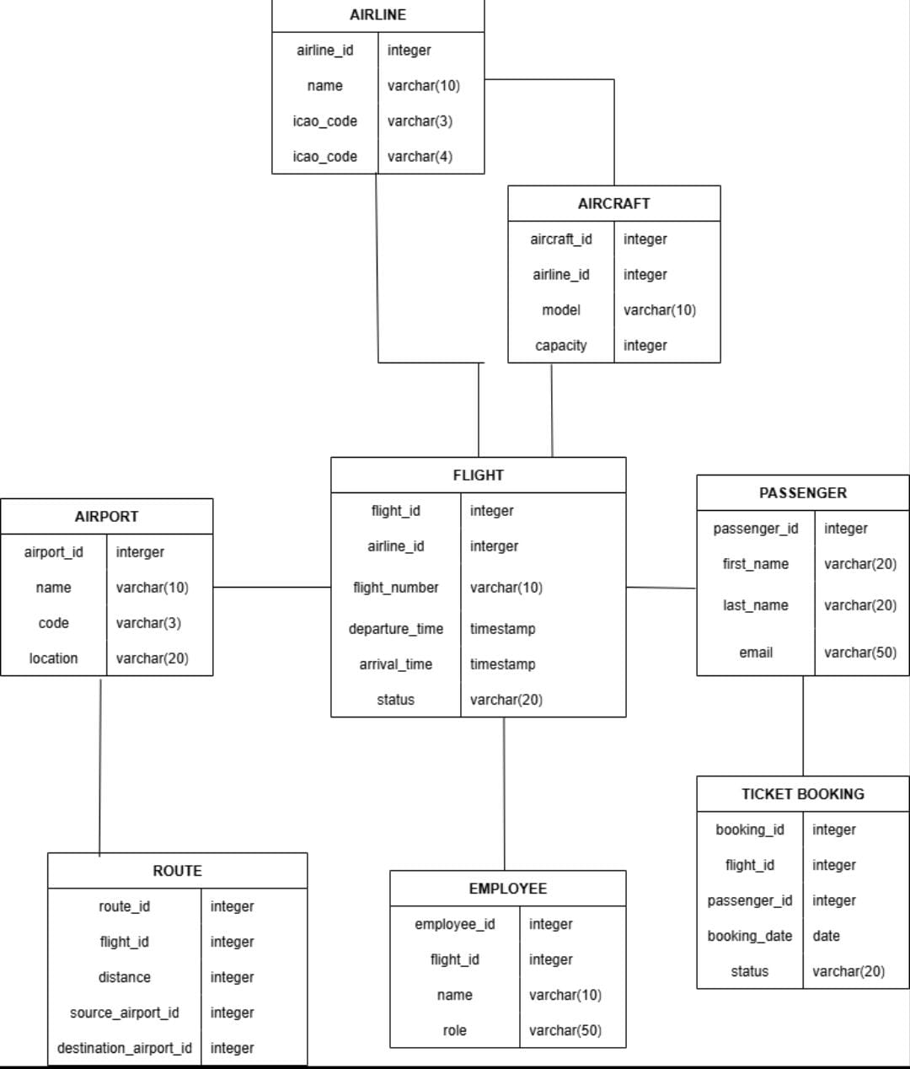

Entities and Attributes:
Airline (airline_id,name,icao_code)
Aircraft (aircraft_id,airline_id,model,capacity)
Airport (airport_id,name,code,location)
Flight (flight_id,airline_id,flight_number,departure_time,arrival_time,status)
Passenger(passenger_id,first_name,last_name,email)
Ticketbooking (booking_id,flight_id,passenger_id,booking_date,status)
Employee (employee_id,flight_id,name,role)
Route (route_id,flight_id,distance,source_airport_id,destination_airport_id)

Relationships:
- Customer ↔ Ticket → (One-to-Many via "books")

- Customer ↔ Airline Service → (One-to-Many via "checks")

- Ticket ↔ Payment → (One-to-One via "recieve")

- Airline Service ↔ Classes → (One-to-Many)

- Airline Service ↔ Airline Operator → (Many-to-One via "belongs")

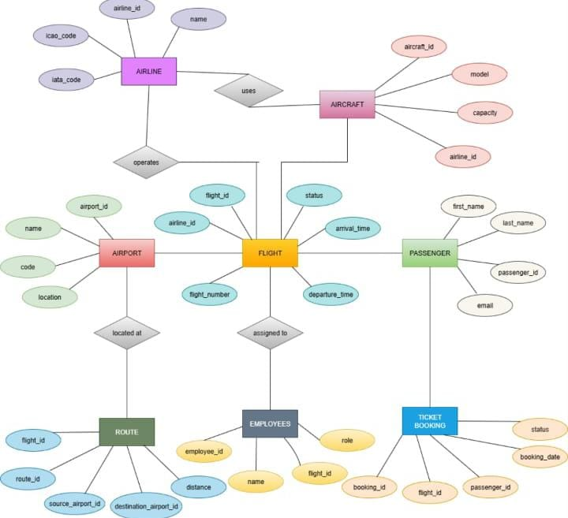

Schema Design (Oracle)
SQL> CREATE TABLE AILINE TABLE ( AIRLINEID INT PRIMARYKEY,AIRLINENAME VARCHAR(100), COUNTRY VARCHAR(50)
);

OUTPUT:

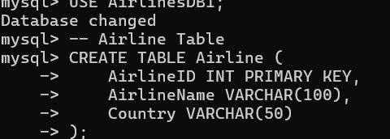

SQL>CREATE TABLE PASSENGER ( PASSENGER ID PRIMARY KEY, PASSENGERNAME VARCHAR(15), GENDER VARCHAR(10),
CONTACTNUMBER VARCHAR(10)
);

OUTPUT:
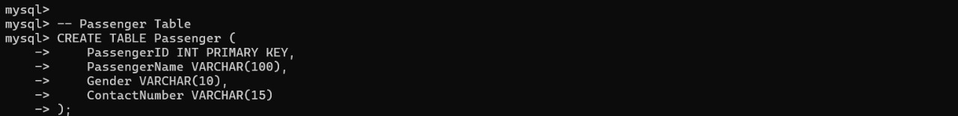
SQL>CREATE TABLE BOOKING
BOOKINGID INT
PRIMARY KEY,
PASSENGERID INT,
FLIGHTID INT,
BOOKINGDATE DATE,
SEATNUMBER VARCHAR(10)
);
OUTPUT:

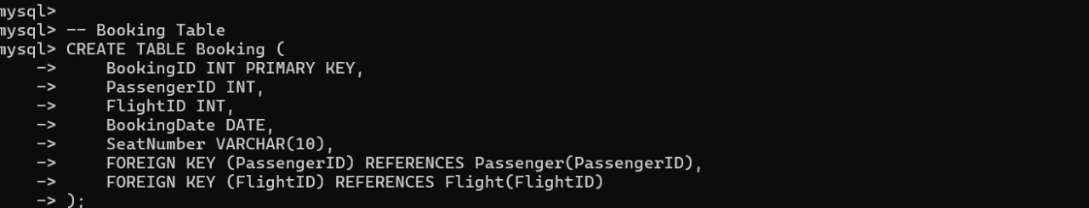

- Normalization 1NF:
Step 1: Ensure First Normal Form (1NF)

Requirement: All attributes must be atomic (indivisible) and there should be no repeating groups.
Check: All attributes listed (e.g., FName, Age, TicketID) appear to be single, simple values. Result:
All relations are in 1NF

Step 2: Achieve Second Normal Form (2NF)

Requirement: The relation must be in 1NF, AND no non-key attribute can be dependent on only a part of
a composite Primary Key (no partial dependencies).

Check AIRLINE_SERVICE: PK = airline\_Id (Not a composite key). No need to check for partial
dependency.

Check ROUTE: PK = (Source, Destination). Source and Destination are part of the key. No non-key
attributes. No issues.

Check CLASSES: PK = (airline\_Id, Type). Non-key attributes are Fare, Category.
Functional Dependencies (FDs):

\text{(airline\_Id, Type)} \rightarrow Fare (The fare is determined by the airline and the class type).
\text{(airline\_Id, Type)} \rightarrow Category (The category is determined by the airline and the class
type).

Step3:Third Normal Form (3NF) A relation is in 3NF if it is in 2NF and there are no transitive dependencies. A transitive dependency
occurs when a non-key attribute is functionally dependent on another non- key attribute. (i.e., PK\rightarrow \text{Non-Key A} \rightarrow \text{Non- Key B})
Normalization Output
1NF (First Normal Form):
- All relations have atomic attributes and no repeating groups. ✅
- Result: AIRLINE_SERVICE, ROUTE, CLASSES are in 1NF.
2NF (Second Normal Form):
- All relations are in 1NF.
- No partial dependency on a composite primary key. ✅
- Result: AIRLINE_SERVICE, ROUTE, CLASSES are in 2NF.
3NF (Third Normal Form):
- All relations are in 2NF.
- No transitive dependency among non-key attributes. ✅
- Result: AIRLINE_SERVICE, ROUTE, CLASSES are in 3NF.

9.Implementation (SQL Queries)

INSERT ELEMENT:
SQL>INSERT AIRLINE
INSERT INTO AIRLINE VALUES(1,’AIR INDIA’,’INDIA’);

SQL>INSERT INTO FLIGHT(FLIGHT ID,FLIGHTNUMBER, SOURCE , DESTINATION ,DEPARTURETIME , ARRIVALTIME ,CAPACITY)
VALUES(101,’AI202’,’NEW DELHI’,’MUMBAI’,’2025-10-20 09:00:00’,’2025-10-20 11:30:00’,180);

SQL>INSERT PASSENGER
INSERT INTO PASSENGER VALUES(201,’RIYA SHARMA’,’FEMALE’,’9876543210’);
INSERT INTO PASSENGER VALUES(202,’AMIT VERMA’,’MALE’,’9123456780’);

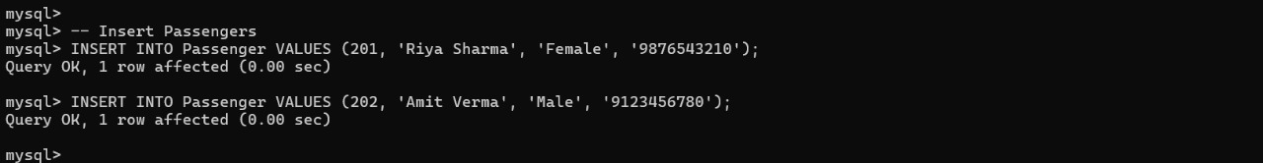

SELECT OPERATION:

SQL>SELECT*FROM AIRLINE;

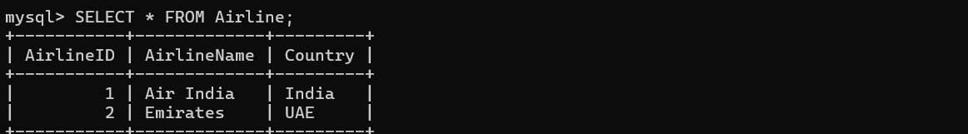

SQL>SELECT*FROM PASSENGER

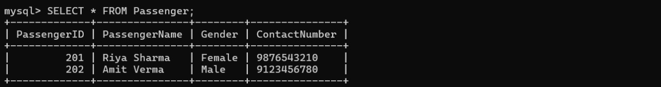

SQL>SELECT*FROM FLIGHT;

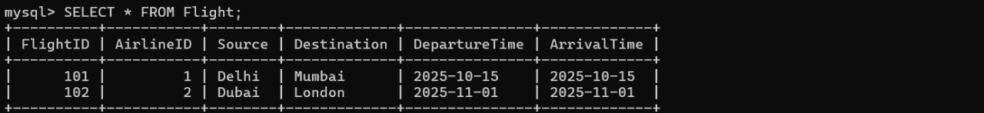

Input and Output
**Sample Input Queries:**
SQL>INSERT AIRLINES
INSERT INTO AIRLINE VALUES(1,’AIR INDIA’,’INDIA’);
SQL>SELECT*FROM AIRLINE

**Sample output:**

Integration with MongoDB (NoSQL)

- Passengers collection
{
"_id": 1, "passenger_id": "P101", "name": "Ravi Kumar",
"email": "ravi@example.com", "contact_no": "9876543210", "bookings": ["TKT101", "TKT102"]
}
- Airline collection
{
"_id": 1,
"airline _no": "12045", "airline_name": "Shatabdi Express", "source_station": "NDLS", "destination_station": "BCT", "type": "Superfast",
"schedule": [
{"day": "Monday", "departure": "06:00", "arrival": "18:30"},
{"day": "Wednesday", "departure": "06:00", "arrival": "18:30"}
]
}
3 Insert in flights
db.flights.insertOne({
_id: "FL123",
airline: "AirAsia",
origin: "DEL",
destination: "DXB",
departureTime: "2025-10-17T09:00:00Z",
arrivalTime: "2025-10-17T13:00:00Z",
status: "SCHEDULED",
aircraft: { model: "Boeing 737", capacity: 180 },
seatsAvailable: 120
});
}
4.Insert data in booking
db.bookings.insertOne({
_id: "BK789",
flightId: "FL123",
passengerId: "P1001",
seat: "12A",
class: "ECONOMY",
bookingDate: "2025-10-10T12:00:00Z",
paymentStatus: "CONFIRMED"
});
5 Inserting data in passenger
db.passengers.insertMany([
{ _id: "P1001", name: "Aarav Mehta", email: "aarav@example.com", phone: "+91-9876543210" },
{ _id: "P1002", name: "Riya Sharma", email: "riya@example.com", phone: "+91-8888888888" }
]);

Results and Discussion:

A well-implemented airline management system (AMS) automates complex operations, leading to significant improvements in efficiency, customer satisfaction, and profitability. By centralizing functions such as ticketing, flight A scheduling, and inventory management, the system replaces time-consuming manual processes with a streamlined digital workflow. This results in faster response times for tasks like booking and cancellations and a reduction in costly human errors. The integration of advanced features, such as dynamic pricing and AI-driven analytics, further optimizes revenue by allowing airlines to adjust fares based on real-time market demand

Conclusion

An airline management system's conclusion is that it successfully streamlines operations by automating functions like booking, payment, and schedule management, leading to improved efficiency, accuracy, and a better customer experience. By replacing manual processes, these systems reduce errors, provide real-time updates, and offer 24/7 accessibility for customers, which is crucial for the airline industry

References

- Oracle Database Documentation – Oracle Corporation
- MongoDB Official Documentation
- Sillberschatz, Korth, Sudarshan- Database System Concepts
- Raghu Ramakrishnan Database Management System

